1. What is Boolean? Write down 3 different expression that results a Boolean type.

A Boolean value is either true or false.

3 different expressions:

100==(1+2)

j = “hel”

j + “lo” == “hello”

age=18

old_enough_to_drink= age>=21

print(old_enough_to_drink)

1. What is a flow chart? Draw flow chart for the following code snippet: (you can draw on a paper, take a picture of it)

Flowchart is a graphical representation of a computer program in relation to its sequence of functions (as distinct from the data it processes).

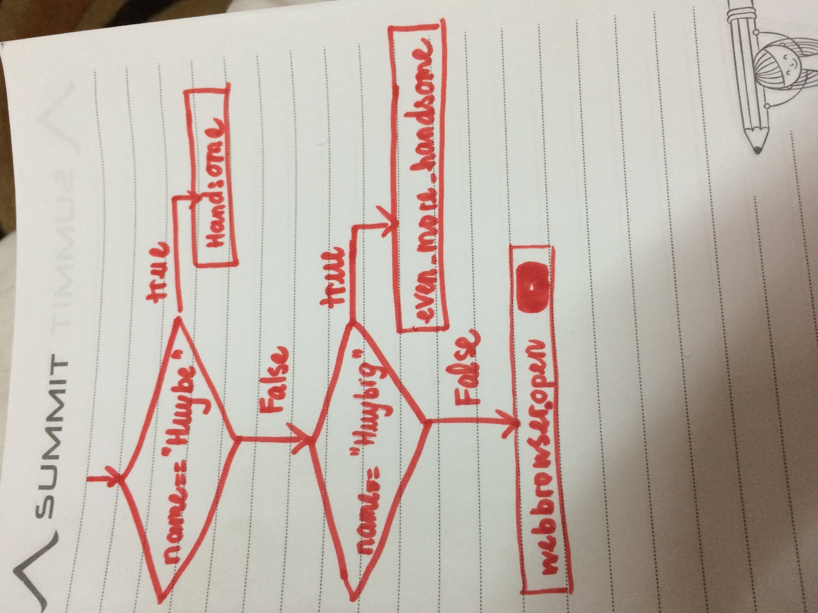

1. What is nested conditionals? Write a piece of code that uses nested conditionals

Nested conditionals happen when one conditional can also be nested within another.

age=21

if 0<age <18:

print("not old enough either to drive or to drink")

else:

if age<21:

print("old enough to drive but not enough to drink")

else:

print("old enough to both drive and drink")